Diego Cabrera Screenshots
Screenshot 1 – Login Screen with MDC Logo
Figure 1. Login Screen
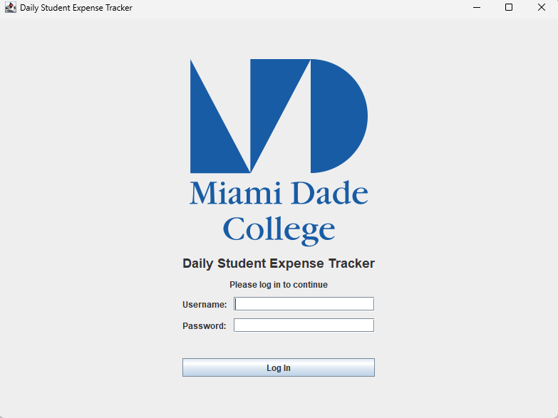
Description:
The application launched successfully and displayed the login screen with the Miami Dade College logo centered above the application title. No errors occurred during startup.
Status: PASS

Screenshot 2 – Empty Login Fields
Figure 2. Login Validation
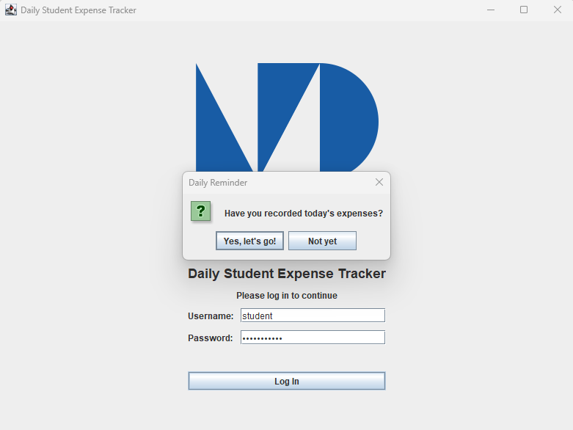
Description:
Attempting to log in without entering a username or password displayed the appropriate validation message. The application prevented login and no failed attempt was counted.
Status: PASS

Screenshot 3 – Incorrect Password
Figure 3. Failed Login Attempt
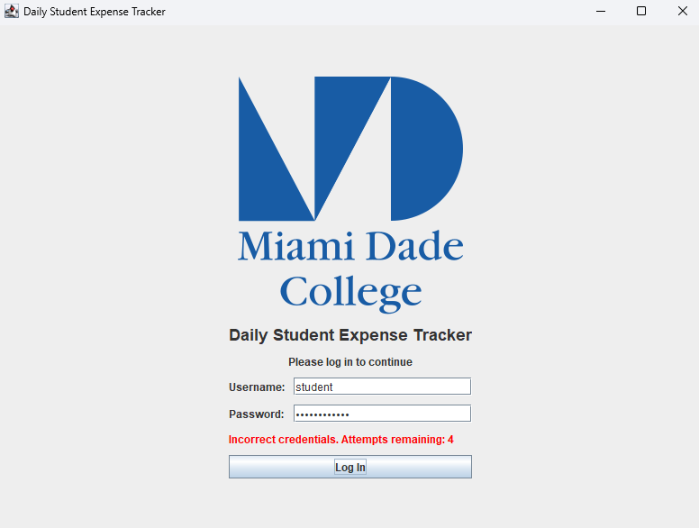
Description:
Entering an incorrect password displayed the remaining login attempts. The application correctly reduced the available attempts by one.
Status: PASS

Screenshot 4 – Account Lockout
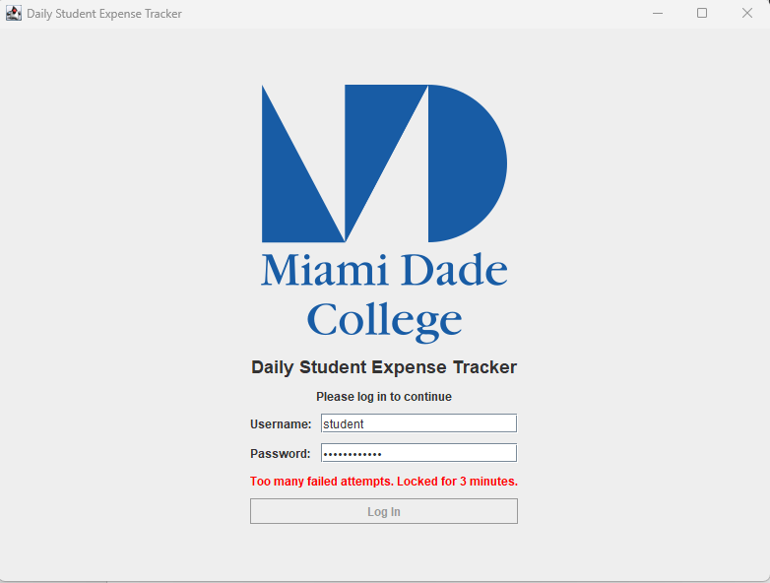
Figure 4. Login Lockout
Description:
After five consecutive failed login attempts, the application displayed the lockout message and disabled the Log In button for three minutes.
Status: PASS

Screenshot 5 – Successful Login
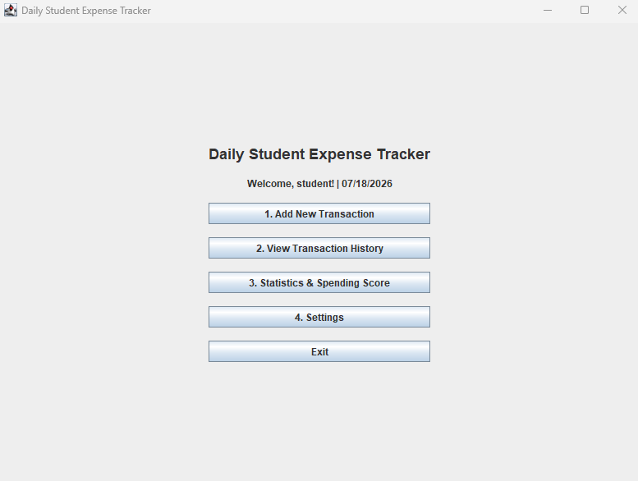
Figure 5. Main Menu
Description:
After entering valid credentials, the application successfully logged in and displayed the main menu with all navigation options.
Status: PASS

Screenshot 6 – Password Changed Successfully
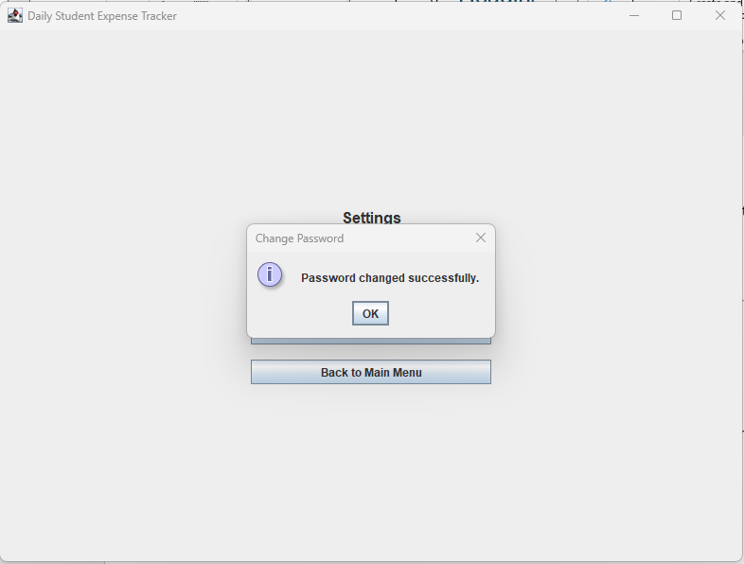
Figure 6. Change Password
Description:
The Change Password feature accepted the correct current password and matching new password, displaying a confirmation message after the password was successfully updated.
Status: PASS

Screenshot 7 – Incorrect Current Password
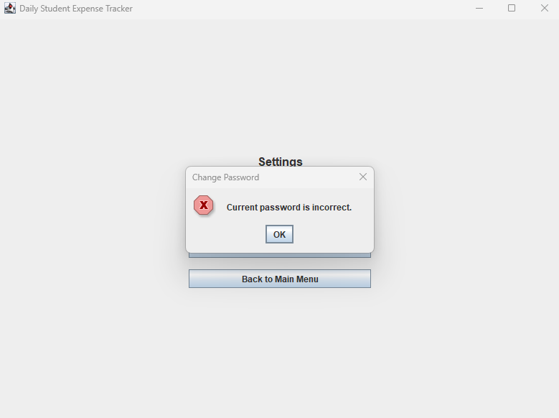
Figure 7. Password Validation
Description:
Entering an incorrect current password displayed the appropriate error message and prevented the password from being changed.
Status: PASS

Screenshot 8 – Add Transaction Screen
Figure 8. Add Transaction
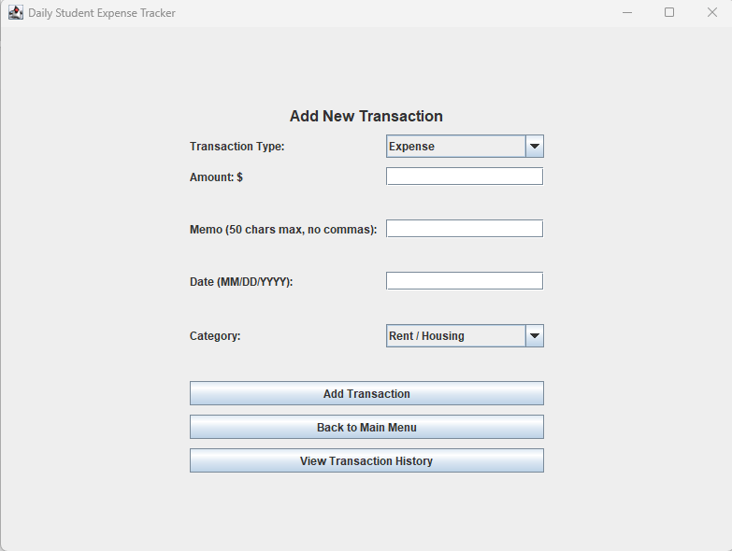
Description:
The Add Transaction page displayed all required fields, including transaction type, amount, memo, category, and transaction date.
Status: PASS

Screenshot 9 – Multiple Validation Errors
Figure 9. Input Validation
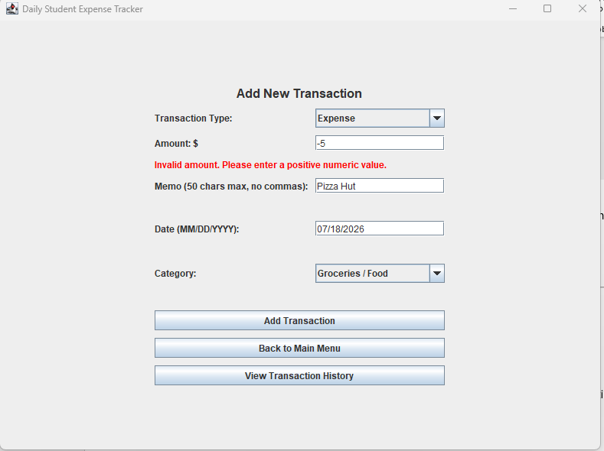
Description:
Invalid values entered for the amount, memo, and transaction date generated validation messages simultaneously without adding the transaction.
Status: PASS

Screenshot 10 – Successful Transaction
Figure 10. Transaction Added
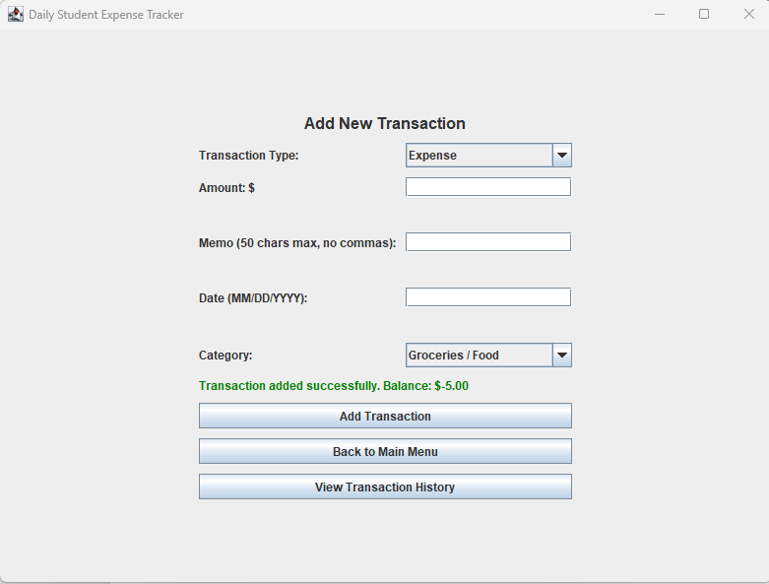
Description:
A valid expense transaction was successfully added to the ledger. The application updated the balance and displayed a confirmation message.
Status: PASS

Screenshot 11 – Income Categories
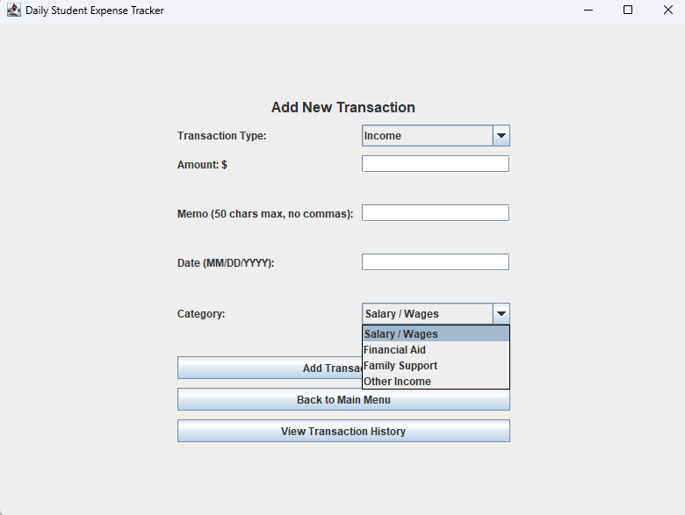
Figure 11. Income Categories
Description:
Selecting the Income transaction type displayed only the available income categories.
Status: PASS

Screenshot 12 – Expense Categories
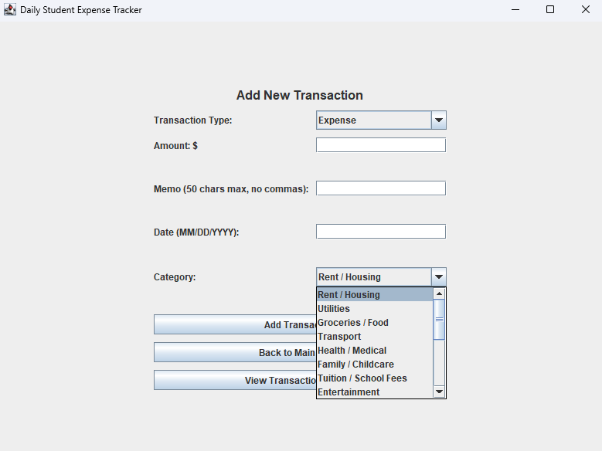
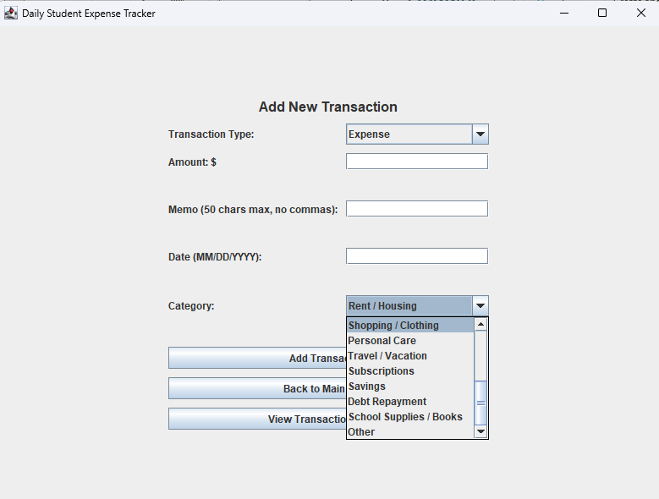
Figure 12. Expense Categories
Description:
Selecting the Expense transaction type displayed the complete list of expense categories.
Status: PASS

Screenshot 13 – Clear Transactions
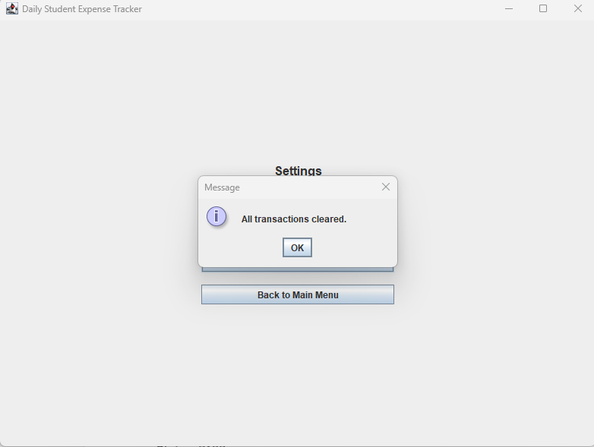
Figure 13. Clear Transactions
Description:
The application displayed a confirmation dialog before permanently removing all transactions from the ledger.
Status: PASS

Screenshot 14 – Empty Ledger
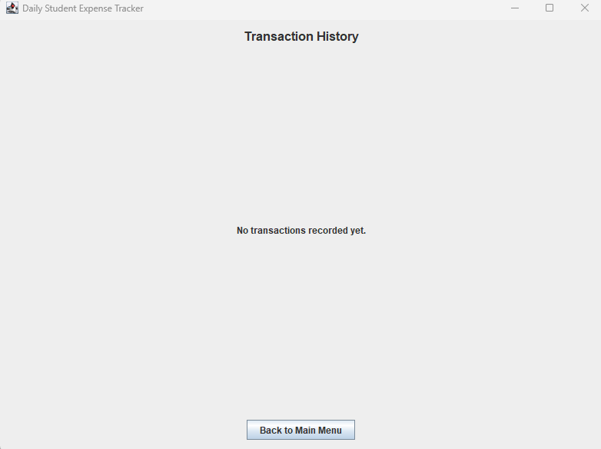
Figure 14. Empty Transaction History
Description:
After clearing all transactions, the History and Statistics pages displayed the appropriate messages indicating that no transactions were available.
Status: PASS

Screenshot 15 – Save on Exit
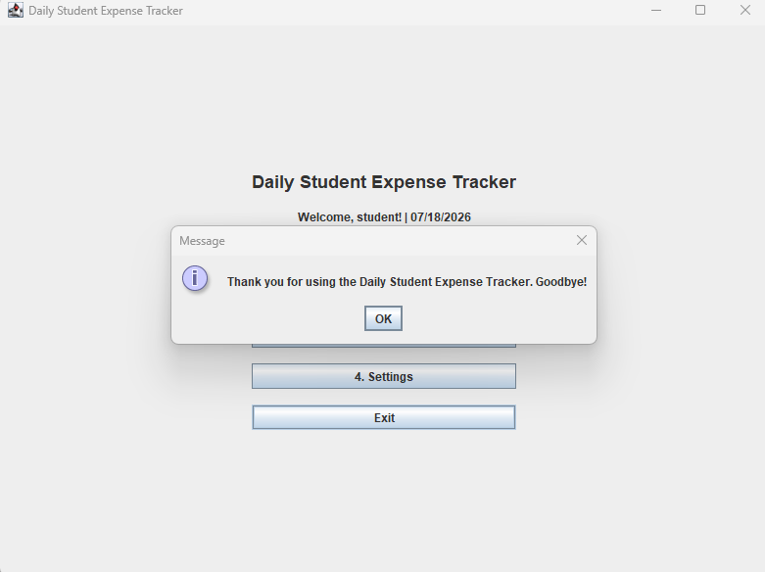
Figure 15. Save Confirmation
Description:
Selecting Exit successfully saved the transaction data to the CSV file before closing the application.
Status: PASS

